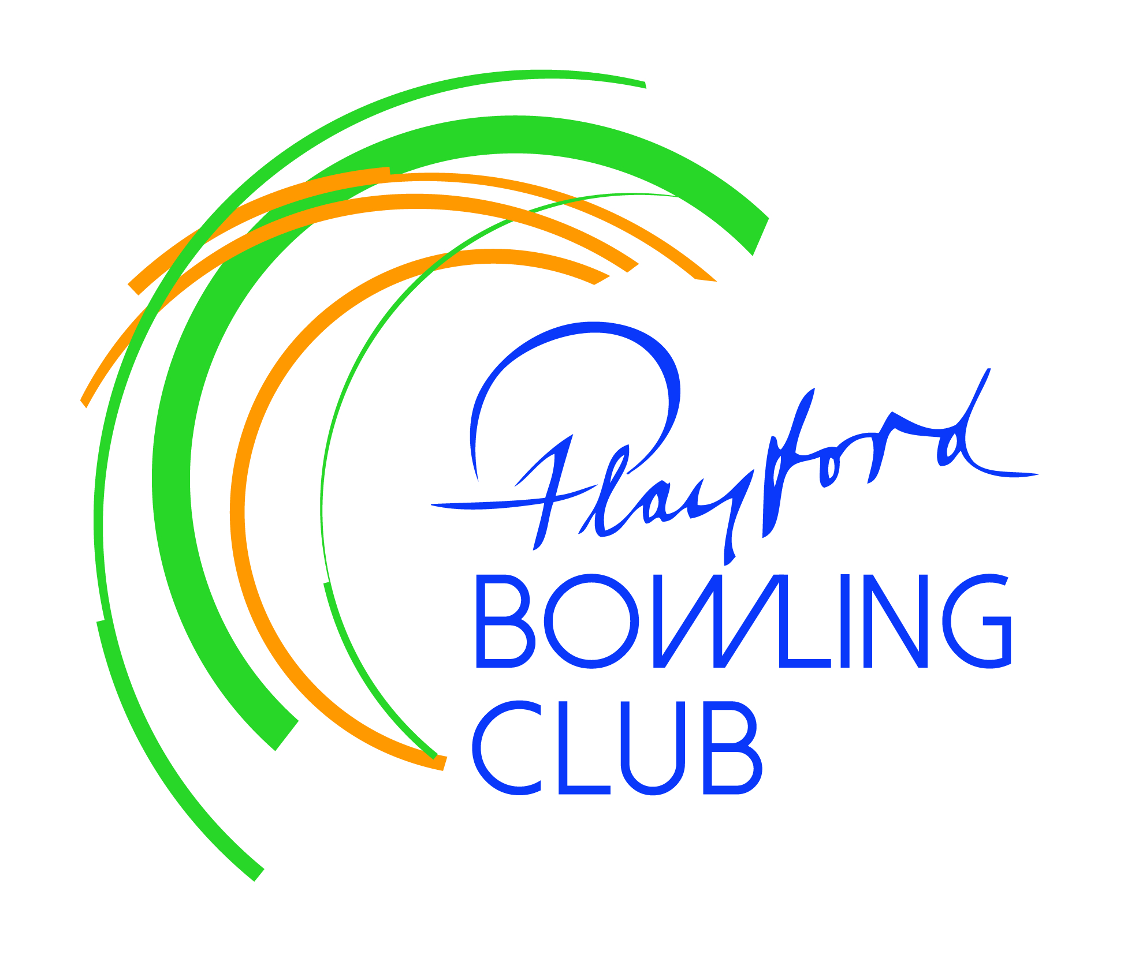
Playford Bowling Club Inc.
PO Box 34 Elizabeth SA 5112

March Newsletter

President’s Report

The Finals Series are almost upon us once again and it’s pleasing to report that 4 of our 10 pennant sides have earned the right to participate, with another 2 finishing fifth and narrowly missing out. Congratulations to all the qualifying teams - those involved would be appreciative of your support as they chase those elusive pennants! Our finals participants:

Ladies Div 2 finished 4th, first round of finals at Modbury, Thursday March 5

Saturday Div 3 finished 1st, first round of finals at Playford, Saturday March 7
Div 4 finished 2nd, first round of finals at Hope Valley, Saturday March 7
Div 5 finished 3rd, first round of finals at Para Hills, Saturday March 7

Once the finals have been completed we’ll go back to our popular Wed/Sat social bowls sessions.
As daylight saving time draws to an end the Tuesday and Thursday night bowls events will soon be winding up. Many thanks to Ron Slager - who has overseen the Tuesday social bowls - and to Tel Bettens – who has run the Thursday Triples competition – for their efforts over the past 5 months.
Huge thanks also to Sherryl and Anne-Marie for providing suppers each Thursday night.

Members will be aware that we recently raised funds for the Natimuk Bowling Club in Victoria, which was destroyed in a bushfire that went through Western Victoria on January 9. This was an initiative of Kevin Bettens, president of Wasleys bowling club, which suffered a similar fate in the Pinery fire about a decade ago. Kevin plays for us on Wednesdays and when we learned of his plans your board decided to join the cause. Anyway each club has now forwarded $2500 to assist the re-building process. We recently received the following e-mail from their secretary:

Hi Craig
We are truly humbled and moved by your generous donation.

On behalf of The Natimuk Bowling Club, l would like to extend our heartfelt thanks and gratitude to you and all members of The Playford Bowling Club .It means a lot to our little club after experiencing such a devastating loss .We have already started planning for our rebuild.

Kind Regards. Graeme Brown Secretary

February’s fund-raising was in aid of Bowls SA’s “Pink Round” campaign, raising money to support research into women’s health issues - we forwarded $500. We are pleased to be able to support deserving local or national organizations, through a monthly raffle and Lucky Squares cards. You can help by buying tickets for these special raffles.

Steve Attridge

Vale

We regret to advise the passing of two former members, Max Symons and Frankie van den Hoevel.

Max was a long-term bowling member of both Elizabeth and Playford bowling clubs. He was an active contributor to the life of both clubs and up until a year ago was still helping with the clean-up after our Thursday night bingo sessions.

Frankie played for Elizabeth BC for many years and during that time was one of the prime tournament organisers. Until recently he was a regular participant in our winter social bowls sessions and he also played in one of Playford’s 8-ball teams.

New Sponsors

Last month we welcomed Roof Rescue as a new club sponsor. If you have any roof issues contact Darren Chammings on 0417 444 182.

This month we are delighted to also welcome Chip’s Window Cleaning on board. Rhys (Chip’s son) cleans solar panels as well as windows and gutters and can be contacted on 0497 735 849.
He has already cleaned the club’s windows and the Eckerts’ solar panels.

James Frencken is based at the Craigmore office of LJ Hooker and is personally sponsoring our club. If you have any real estate questions/requirements contact James on 0476 871 921 – Sue and I have already touched base for advice. James popped in for a drink last week with his dad, who’s President of Hamley Bridge Bowling Club.

Signage for these new sponsors will soon be installed on our southern boundary fence.

Miscellaneous

Many thanks to Dean Huntley, Michael Keenan and Charlie Lang-Ashe, who continue to run our Junior Bowls Programme each Saturday morning. There are usually about 10 very enthusiastic participants, one of whom (Dean’s daughter Hannah) has already played 3 pennant matches with her dad, while another shows great promise and has recently become a member of our club.

A new Bingo roster is on the office noticeboard and once again we thank those members who regularly turn up on Thursday nights to support the club’s most important source of income. If anyone has a problem with any of the dates allocated please let me know and we’ll arrange a stand-in. If anyone else would like to join our merry band, please see me – the more volunteers we have, the less frequent the demands on each individual.

A certain gentleman who likes bananas and is often called up to fill in for a pennant team playing at home says he prefers playing pennant to social bowls, because he saves a dollar and gets a free sandwich! The other social bowlers prefer it too, as they have some chance of winning the money!

Club championships – Singles and Doubles competitions must be completed by March 20th.

Off-season Fours and Triples competitions will begin April 26th and May 3rd respectively.

